Computer Science 378: Introduction to Database Management Assignment 3

Assignment 3
Due: After Unit 8
Total: 100 marks
Weight: 15% of your final grade

Answer all questions in this assignment. Submit your completed work to your Academic Expert for
marking and feedback using this Assignment Drop Box.

1.Question 1
  - (12 marks) Answer the following questions (250 words max/question).
- What are the typical integrity controls performed in both data integrity and referential integrity?
  - Data Integrity controls are designed to ensure that the data being committed to the database adheres to specific rules and specifications. These controls ensure that the data follows certain typing, data sizes, whether null values can be stored or not, or even that the data must be of a specific masking or set of values. These controls are enforced before inserting new records, or when updating existing. Types of data controls can be CHECK constraints, validation during triggers, data column definitions.
  - Referential integrity is enforced by creating relationships between columns with two or more tables. Key(s) are identified as foreign keys between a parent and child table. The child table contains a foreign key that points to records within the parent table. Newly inserted/updated data within the child data is verified against the parent table, to ensure that it exists and is valid. This ensures that the child table cannot refer to data that is not valid. Parent data cannot be removed or altered when child data is referring to it as well, unless if the delete is a cascade delete type. A cascade delete on a parent record will delete any child record referring to the parent record first, and then the parent record. Relationships can be nullable as well, indicating that the child record does not refer to any record within the parent table.
- Using an example for each situation, illustrate the three common situations that suggest relations should be denormalized.
  - The three common situations that suggest relations should be denormalized are: two entities with a one-to-one relationship, associative entity with nonkey attributes and reference data.
    - Two entities with a one to one relationships can be denormalized into a single entity, as it can reduce unnecessary joins, and does not provide any performance or storage savings, and only increases complexity. An example of this could be an Employee table and an EmployeeDetails table. There is always one row for each Employee record as there is for each EmployeeDetail record. They could be combined.
    - Associated entity with nonkey attributes is best demonstrated with many to many relationships, are tables that are frequently queried against, and can greatly increase the complexity of a model or relationship. An example of this could be a students record database, with a student record, course record, and studentcourse record. The studentcourse record would have the marks and enrollment dates and would be queried against frequently. In this situation it’d be better to merge the results of Student and StudentCourse table into one, ie: StudentCourseSummary, with StudentId, Name, CourseID, CourseName, Mark, EnrollmentDate.
    - Reference data is data that exists in one to many relationships, and does not frequently change. If the table is rarely changed and constantly queried, then it’s a good candidate to include as additional attributes of the table. An example of this could be a car dealerships inventory, where the fuel type is listed as gas, hybrid or electric. Those values hardly change, so they could be included as additional columns of the CarListing table.
- What are the advantages and disadvantages of horizontal and vertical partitioning?
  - Partitioning is the practice of physically splitting data across tables to better isolate related data in logical or functional arrangements. This can improve performance of data sets, and make them more manageable.
  - Partitioning can be achieved in two ways:
    - Vertical partitioning, where a large table with many columns is split into multiple tables across columns. This can be very advantageous because if certain columns or pieces of data of an entity are infrequently queried, or changed, than they can be left out of the more frequently accessed or altered data.
    - Horizontal partitioning is the splitting of data by rows into multiple tables, taking a large data set into several smaller ones. The definition of the data remains the same, each table contains the same columns. This is most effective when tables contain extreme large data sets. Partitioninig can be done by date, identity or identifier, or ranges or more. Splitting a very large data set into smaller data sets can improve performance of both querying and modifying data.

2. Question 2
  - (9 marks) Answer the following questions (250 words max/question).
- What factors should be considered when choosing a file organization?
  - The seven factors to be considered for a file organization are:
- Fast data retrieval
- High throughput for processing data input and maintenance transactions
- Efficient use of storage space
- Protection from failures or data loss
- Minimizing need for organization
- Accommodation of growth
- Secured from unauthorized use
- What is the purpose of clustering data in a file?
  - Clustering of data in a file is the practice of combining two different tables of data together in one file block. This is best used when the two tables are frequently accessed together. It reduces data lookup and retrieval time since an entire page can be read at once.
- Compare hashed file organization versus indexed file organization. List two advantages of indexed over hashed and two advantages of hashed over indexed.
  - Hashed and indexed file organization are file organization strategies that both sort files based on assigning identifiers that allow for faster retrieval of data. How the records are identified is different however; indexes assign a sequential or non-sequential identifier to each record and store those indexes within another table. When retrieving data, the index table allows the individual record directly. Indexes can also be used to describe several records; these are called secondary indexes. Indexes do require some additional space for indexing tables, however, do not require the large empty blocks that hasing does. Indexes support easy retrieval of multiple indexes, and updating of records is easy and fast.
Hash file organization is the process of organizging file addressing based on an hashing algorithm. Hash organization allows for very reading, writing and updating, they’re also very fast at retrievals using equality operations. Hashing, however, requires more storage space and do not support sequential retrieval.

3. Question 3

(12 marks) Consider the following database project with these tables:
- Employee (emp-no, name, department, salary),
- Project (proj_no, name, location, budget, manager_emp_no)
- ProjAssigned (emp-no, proj-no, worked-hours)
Write a SELECT SQL query to list the numbers and names of all employees with a salary greater than 66000 who are assigned to projects and list the project name and location they are assigned to as well as the corresponding hours worked for each project. Your list should be sorted by employee name.
SQL:
select
emp.emp_no, emp.name as Emp_Name,
proj.name as Proj_Name, proj.location as Proj_Location, pa.worked-hours
from
employee emp
inner join ProjAssigned pa on pa.emp_no = emp.emp_no
inner join Project proj on pa.proj_no = proj.proj_no
where emp.salary > 66000
order by emp.name asc

Define indexes on selected attributes to speed up your query. Justify your selections.
Write SQL queries to create the indexes you defined above.
SQL:
CREATE INDEX idx_EmpNo on Employee (emp_no)
--This is only required if emp_no is not a primary key.
--Provides faster retrieval of records from emp table using emp_no
CREATE INDEX idx_EmpName on Employee (name)
--This is an optional column that can assist with sorting of records.
--Only required if the results returned are very large.
CREATE INDEX idx_ProjNo on Project (proj_no)
--Similar to idx_Emp, only required if proj_no is not a foreign key.
CREATE INDEX idx_PA_Proj on ProjAssigned(proj_no)
CREATE INDEX idx_PA_Emp on ProjAssigned(emp_no)
--These indexes speed up join operations for the ProjectAssigned table, using columns that are used for each query.

4. Question 4

(9 marks) Suggest the most appropriate security measures for each situation described below.
- The Western Union bank uses an electronic funds transfer (EFT) system to transmit sensitive financial data between its branches all over the world.
The EFT data being transmitted by the EFT system with the various branches must be protected against interception, interruption and reception. That means that the data must get through, without anyone being able to interrupt the process, alter the contents of the data, or be able to capture or read the data. This should be done by protecting the means of communication between the two systems; if possible it should be an air-gapped direct physical connection, disconnected from any public networks. If public infrastructure must be used, such as the internet, then an encrypted connection is a must, ideally involving a dedicated virtual private network. Connection filtering, authorization and authentication should be involved, such as; verifying IP address, MAC address, username / password / token / key or other form of authentication, and authorization, which is the process of identifying the connector (such as a branch) and ensuring they’re only permitted to execute authorization actions, or view data they should be permitted to. Encryption of protected data should also be impelemented, where the protected data is stored in an unreadable fashion, and transmitted unreadable to the distributed branches, which must then have a private key to be able to read the data.

- A fighter jet simulation company has set up an off-site computer-based training centre for the F-35. The company wishes to restrict access to the site to authorized employees. Since each employee's use of the centre is occasional, it does not wish to provide the employees with permanent keys to access the centre. (Assume the company stores employee information as well as assigned keys on a database.)
If the company doesn’t want to issue permanent keys to the employees, a password or biometric verification would be the best option. A password could be enabled or disabled easily remotely, and not require that the employee have any physical key. Another option would be to use employee biometric information such as a fingerprint, voice confirmation, or retina scan to authenticate the user against scans obtained during employee onboarding.
- A golf course uses a simple password system to protect its database. They created a new website to allow both its members and its employees to use the new web-based system to access and update information. They find it needs a more comprehensive security system to grant different privileges (such as read-only versus create or update) to different users.
The best method to properly to protect the database and system would be to create a new user management module within the database. Create a new list of users and assign each user a password. Do not share the ‘simple’ database password, it would be used only for authentication between the database and the golf system application. If possible, and feasible, it’d be ideal to apply roles-based permissions, implementing a least permission methodology, and actively maintaining the user list; revoking permissions and roles when a user leaves the group. It would also be best practice to implement additional connection authentication checks such as address filtering, VPN connection etc and thorough auditing of all connections and actions.

5. Question 5

(9 marks) Suggest an appropriate recovery technique a database administrator could use to resolve each of the following situations.
- A disk drive fails during regular operations while an employee is entering data about newly registered students.
Depending on the database and hardware configuration, some or all of the database and transaction can be restored. If the storage device that the database is installed on supports RAID mirroring, then it should be possible to restore the database to the last successful write, and use the in memory transaction log to restore the last executed SQL command. That would be an ideal situation and require a very specific set of conditions.
Database best practices calls for externally stored full backups to be run on a regular basis and partial backups on a very frequent basis. If the database is so negatively impacted by the drive failure, then a recent backup can be restored from the external source.
No matter what the recovery option is, a new hard drive should be obtained immediately, even a partially failed could lead to further failures.
- The registration office at a university entered an incorrect amount for a student tuition payment. The error was discovered by the financial services department several weeks later.

Since the error was only discovered weeks later, then the error would probably have already been reported on or reconciled with other departments or financial concerns. This means the best course of action would be to enter a financial correction for the current date in the amount of the error. This would ensure that previously generated reports would remain valid.

- The database administrator of a financial institution performed a full database backup but forgot to activate the journalizing facility. After, data entry clerks at the financial institution entered transactions for two hours before the database became corrupt. It is discovered that the journalizing facility of the database has not been activated since the backup was made.
Unfortunately recovering changes to a database after a backup was taken, and without any journaling, then its almost impossible to rerun any of the SQL commands or transactions. The only chance would be if a custom external archive log, or log of commands is taken. Increasingly cloud based applications implement telemetry by default meaning that there is a good chance that the actions could be restored.

6. Question 6

(12 marks) Answer the following questions (250 words max/question).
- Contrast data warehouse versus data mart.
A data warehouse is a cleaned, integrated, structured data repository used for analysis and decision making. A data mart is a much more limited in scope version of data warehouse, often focusing on a department or specific subset of a data warehouse. Data marts are designed to optimize the performance for well-defined and predictable uses.
- Identify the major differences between the following forms of data integration: data federation and data propagation.
Data federation is the process of creating a virtual view of data from another source and applying a data transformation, it does not involve storing or transferring of information. Data propagation however is the process of physically copying the data from external source to another.
Both situation source data from external sources, however the main difference is the one involves keeping a copy of the data locally; data propagation. Each approach can be appropriate depending on the situation. If the external source data is always available and retrieval isn’t to resource expensive, then it would be the best situation, as there is only a single source of truth. If however, retrieval of that data is either slow, or not 100% available, then taking a copy would be a good option, in which case propagation should be used.
- In a diagram, present the main components of the Hadoop architecture and show their interconnections.
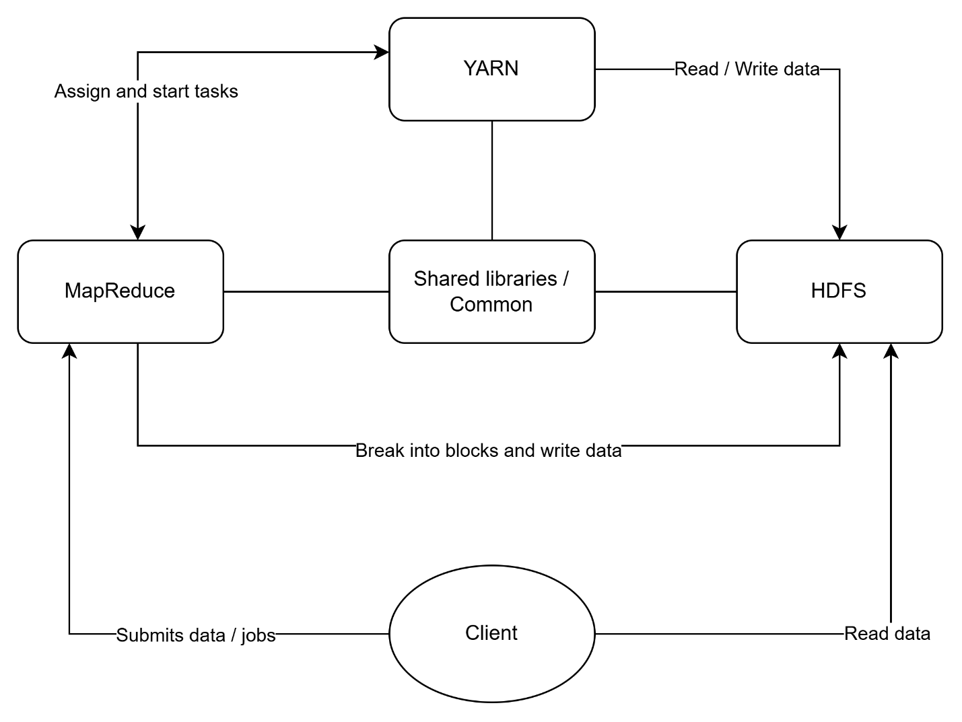

- Contrast the following types of data analytics: descriptive analytics, predictive data analytics, and prescriptive analytics.
Data analytics is the act of converting raw data into meaningful insights by applying statistical analytical and computational techniques.
Descriptive analytics is data analysis that focuses on reviewing what happened by summarizing historical data, identifying patterns and providing visibility into the past.
Predictive data analytics is a type of analysis that examines those describe trends and patterns and extrapolates what could possibly happen in the future. This process may involve performing descriptive analysis first, to extract trends, then apply them to current values to estimate future data.
Prescriptive analysis, is similar to predictive data but instead, it uses the descriptive and predictive data to suggest what course of actions should be taken to influence those established trends in an attempt to guide them in a different direction.

7. Question 7

(13 marks) Consider the following dimensions, dimension attributes, and dimension sizes for Farm
Coop-Insurance:
- Member(member_ID, Name, Address). On average, there are two members for each policy and item covered by the policy.
- InsuredItem(Item_ID, Description, Coverage_Type). There is an average of ten covered items per policy.
- CoopOffice(Office_ID, Address, Manager_name). Each policy is registered and managed by only one office of the cooperative.
- Policy(Policy_ID, Type). The company has approximately one million policies at the present time. Approximately five percent of these policies experience some change each month.
- Period(Date_Key, Fiscal_Period). The length of the fiscal period is one month. The decision system reports are supposed to be based on five years of data.
- Claim(Claim_ID, Claim_Description, Claim_Type).
The facts to be recorded for each combination of these dimensions are Policy_Premium, Deductible, and Monthly_Claim_Total.

Design a star schema for this problem. (5 marks)
Fact grain table:
Member_ID, Item_ID, Office_ID, Policy_ID, Date_Key, Claim_ID, Policy_Premium, Deductible, Monthly_Claim_Total

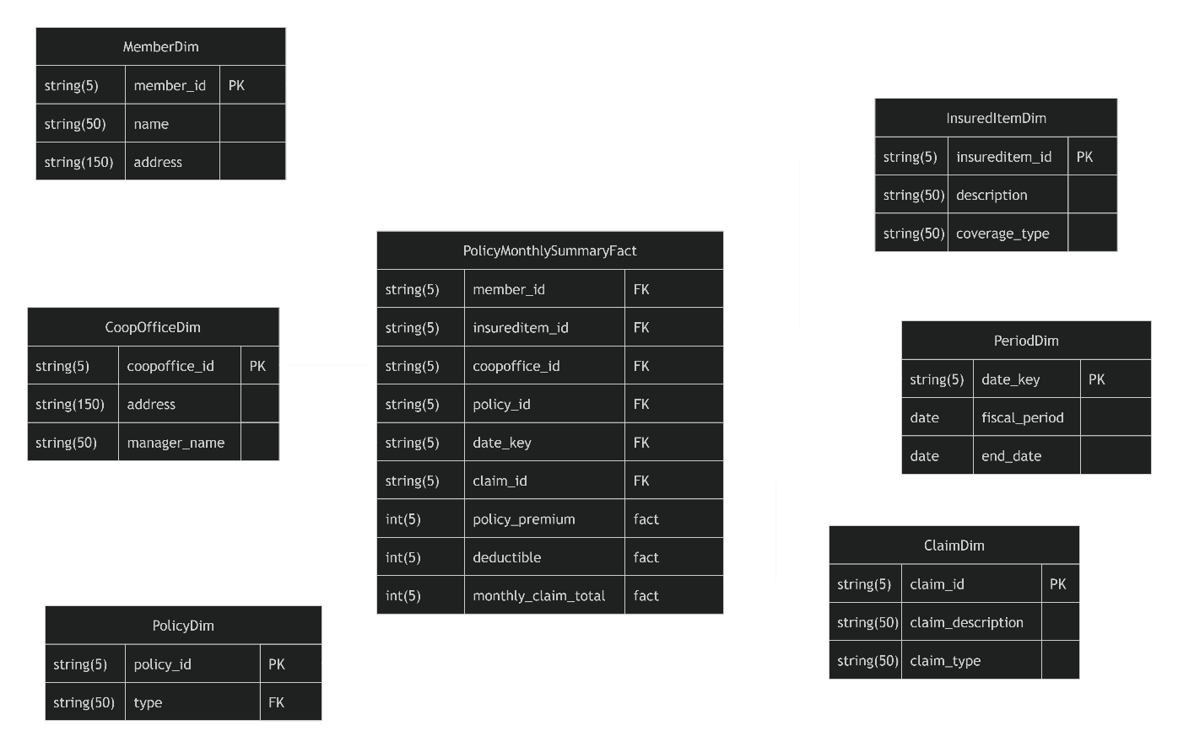

Using the assumptions stated above, estimate the number of rows in the fact table. (4 marks)
5% of policies per month make a claim = 1,000,000 * 0.05 = 50,000
One office per policy = 50,000 x 1 = 50,000 rows
Ten items per policy = 50,000 x 10 = 500,000 rows
Two members per policy = 500,000 x 2 = 1,000,000 rows per month
5 years of months = 1,000,000 x 12 x 5 = 60,000,000
Total estimate rows in fact table = 60,000,000 rows.

Estimate the total size of the fact table (in bytes), assuming an average of 5 bytes per field. (4 marks)
9 fields x 5 bytes = 45 bytes per row.
45 bytes x 60,000,000 rows = 2,700,000,000 = 2.7 GB

  - 8. Question 8
  - (12 marks) For each of the following applications, state which type of NoSQL DBMS would fit the
  - needs of the situation. Justify your answer.

The types of NoSQL DBMS are: Key / Value pair, document stores, wide-column stores, and graph databases.
Key Value: simple key and simple value. Fastest and easiest type, a single value maps to a single key. Great for fast retrieval, caching, session storage etc.
Document Stores: Similar to Key Value, but stores a structured document (usually JSON) instead of a simple value. Great for hierarchical data, or a flexible schema that will allow for evolution.
Column Wide: Data is organized into rows with large numbers of columns, grouped together. Good for large throughput or analytical data involving dates or changes over time.
Graph data: Data is organized by nodes, and edges. Edges describe the relationship between nodes, allowing for quick an easy retrieval of related nodes, or even relationships. Excellent for social networking.

A database that needs to support a relatively complex hierarchical internal records structure that may vary for each record
A document store NoSQL DBMS would be the best selection for this because it allows storage of complex documents, such as JSON objects but also supports hierarchical structures.

A database where the data is particularly well suited to be organized as a network of associations between the data items
Graph data would be best suited to managed data organized as network of associations. This is because graph data DMBS uses nodes and edges to manage the differences between entities and the relationships between them.

A database for which the DMS needs to provide quick access to each of the records by key
value, but in addition to that, must also allow easy access to the components of each record
A document store is a structured set of data, such as JSON, where the individual pieces, not just documents or simple values, but anything is stored with an associated key. This allows easy and quick access to the data, with the ability to modify as well.

9. Question 9

(12 marks) For each of the following data analytics situations, state which type of analytics would address the needs of the organization. Justify your answer.

The three types of analytics are descriptive analytics, predictive analytics and prescriptive analytics.

National Bank of Canada, which is a midsize bank in Canada, would like to provide decision support analytics for its agents in the lending department.
Since the National Bank wants to use analytics to aid in decision making, then it should use prescriptive analytics. Prescriptive analytics uses predictive analysis of descriptive trends to make the most correct, best-informed decisions.
An example of prescriptive analysis performed could be the analysis of a client’s credit, employment and outstanding debts and assets. This could indicate the risk associated with thie client taking additional debt, and to prescribe ideal interest rate and terms.

President’s Choice, which is a large retail chain in North America, wants to understand what factors contributed to the overall sales decline it experienced in a specific month of last year.
Diagnostic analytics uses historical data to identify patterns and relationships that help explain outcomes. Since President’s Choice wants to understand what factors contributed to the sales decline, it should use diagnostic analytics. Diagnostic models can analyze past sales data, customer behavior, promotions, pricing changes, and external factors to determine which variables were most strongly associated with the decline in that specific month.

Ubisoft, which is a video game company, wants to provide all its employees with an up-to-date
graphical representation of the number of downloads of its game products and in-app revenue
associated with them.
Descriptive analysis is the process of extracting data objectively to describe the past status of a system. In this case, Ubisoft wants to gather the real time data of number of downloads of game products and associated revenue. Since this process is extractions and objective representation of data, and does not involve extracting assumptions or predictions out of this data, it would be considered descriptive analysis.

